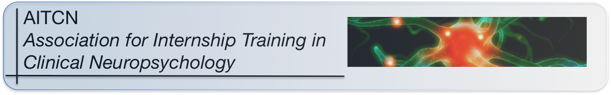

President: Suzanne Penna, Ph.D., ABPP-CN spenna@emory.edu
Past President: Stephen Correia, Ph.D., ABPP-CN stephen_correia@Brown.edu
Secretary/Treasurer: Megan Kramer, Ph.D., ABPP-CN kramerm@kennedykrieger.org
Member-At-Large: Christopher L. Grote, Ph.D, ABPP-CN cgrote@rush.edu

ANNUAL MEMBER ATTESTATION FORM

2022

PROGRAM INFORMATION:
Program Name:
Primary Contact:
e-mail:
phone:
Dues Contact:
(☐ same as above)
e-mail:
phone:
Mailing Address:
Website Address:
Number of intern positions: |  | # = ____
Current year: |  | # = ____
Anticipated next year: |  | # = ____
Number of neuropsychology supervisors: |  | # = ____
List neuropsychology supervisors’
names/degrees/board certification (optional):

MEMBERSHIP STATUS:
APA/CPA Accreditation status (check all that apply): | __ current (date accreditation expires: _____________)  __ renewal pending (optional: describe status below)  __ no longer accredited (optional: describe below)
% Neuropsychology Training: | 1) At least 30% of training time in clinical neuropsychology | ___ YES  ___ NO
Education: | Didactic experiences consistent with Houston  Conference guidelines for knowledge and skill. | ___ YES  ___ NO
Supervision: | Provides supervision by a full-time clinical neuropsychologist. | ___ YES  ___ NO
Adjunctive activities: | Provide adjunctive activities that facilitate socialization, acculturation, and diversification of the intern. | ___ YES  ___ NO

Optional Narrative/Explanations/Comments/Questions:

Please return completed form to:
spenna@emory.edu

